Dewlish parish council
Wardon Hill Farm, Long Ash Lane, Dorchester, Dorset, DT2 9PW
Amanda Crocker, Clerk Tel: 07855 396073 Email clerk@dewlishparishcouncil.gov.uk

Dear Councillor, 22nd September 2026

You are hereby summoned to attend a meeting of Dewlish Parish Council on Monday 28th September 2026 commencing 7.30pm at Dewlish Village Hall.
Amanda Crocker,
Clerk

AGENDA

1. Period for public participation

2. Apologies for absence

3. Declaration of pecuniary and other interests

4. To agree the minutes of the Parish Council Meeting dated 27th July 2026

5. Matters Arising from previous minutes for report only

6. To receive the Dorset Cllr’s report

7. Finance
(a) To note the salary increase of 3.3% as set by the national pay award
(b) To authorise the payment of accounts - attached
(c) To confirm the reconciliation of accounts - attached
(d) To agree the position against budget – attached

8. To receive reports on the following matters and to agree actions
(a) Planning: P/FUL/2026/04530 Druce Higher Barn – Erect shoot lodge and ancillary storage buildings for agricultural and apiary equipment
(b) Police, Traffic and Roads –
(i) Police report –
(ii) Milborne Wood Road Safety
(c) Parish Amenities and Rights of Way

9. To set up a working group to consider the refurbishment of the Green

10. To consider a response to the Boundary Commission Review – Dewlish to move away from the Chalk Valleys Ward and into Milborne and the Winterbornes Ward

11. To receive reports from Parish Councillors

12. Date of Next Meeting

Item 6

Report to the parish council 31/8/2026
Cllr Jill Haynes Chalk Valleys Ward

Dear Councillors, Clerks and members of the public, please find my report for July and August 2026.
The summer months and school holidays traditionally mean that things are quieter at the council but this summer there has been a big change to the development of the councils Local Plan. This has been presented to town and parish councils, but I think it is worth giving this quite a bit of space so that members of the public and those who could not make the presentation understand the current position. The Local Plan is the document which sets out the planning policies which will determine whether a planning application is put up for approval or not. Often the decisions are made by officers, but they also can go to one of the three planning committees, Chalk Valleys Ward comes under Northern Area Planning Committee. The new National Planning Policy Framework has recently been published by central government and I am waiting on a webinar to update us councillors to the changes so more on this next month.

Dorset Council Local Plan
What has changed?
The Government has made major changes to the planning system over the last two years. These include:
- New national planning policies.
- Much higher housing targets – a doubling of current build rates.
- A new system for preparing Local Plans.
- New requirements for councils to work together across wider areas.
For Dorset, the annual housing requirement has increased to around 3,246 homes per year, which is roughly double recent delivery rates.
Why can't Dorset continue with the old Local Plan process?
The Government changes have made it extremely difficult, and potentially impossible, to produce a sound Local Plan under the legacy system before the Government's deadline of 31 December 2026.
Key problems include:
- The plan would need to comply with both old and new national planning policy frameworks.
- New national policies could override some Local Plan policies immediately after adoption.
- Additional evidence would be required to understand the implications of the new higher housing numbers – this needs to be collected sequentially.
- Dorset would need to identify around 550 small housing sites to meet national policy requirements.
- There are risks that problems would only be identified at the final examination stage, when they are difficult to fix.
What is the new system?
The Government introduced new Local Plan regulations in March 2026. The new system:
- Has a formal timetable of 30 months.
- Includes "Gateway" checks throughout the process to test progress and reduce risks.
- Is intended to be simpler and more predictable.
- Links with wider strategic planning across neighbouring council areas through the Spatial Development Strategy.
What is a Spatial Development Strategy?
Under the new arrangements, Dorset will work with neighbouring councils in the wider Wessex area on a Spatial Development Strategy. (The proposed Wessex Strategic Partnership will include Dorset, BCP, Wiltshire, Somerset and East Devon and if agreed by government will be a separate authority with an elected Mayor.)
This will deal with major cross-boundary issues such as:
- Strategic distribution of housing and economic growth needs.
- Strategic infrastructure to support this growth.
- Other large-scale planning matters that affect more than one council area.
This will make it easier to secure infrastructure investment and address issues that cannot be solved by Dorset alone.

What happens to the work already done?
The work completed so far is not wasted! This includes the responses to the consultations that we have undertaken.
- We’ve had feedback on the 250+ potential development sites that we consulted on last year.
- We have policy options being developed.
- We have commissioned and prepared a large amount of supporting evidence.
This information will be used to support the new Local Plan-making process.
What are the advantages of moving to the new system?
Dorset Council believes the new system offers several benefits:
- Greater certainty through the Gateway review process.
- More time to develop and test options.
- Better understanding of community views before final decisions are made.
- Stronger links with neighbouring authorities.
- More opportunity to plan strategically for infrastructure.
- Clearer governance and decision-making arrangements.
Indicative timetable
The Council is proposing to begin the new-system process during 2026, with:
- Early scoping consultation in autumn 2026.
- A series of Gateway reviews and public consultations.
- Submission for examination in 2028.
- Adoption of the Local Plan during 2029
This indicative timetable estimate will be a challenge to meet, and the timetable will need to be updated throughout the process. There are multiple factors that are outside of the Council’s control which may delay the process, which will be managed as best they can be.

What does this mean for local communities?
The main implication is that adoption of the Local Plan may be around six months later than the best estimate timetable under the legacy system. This ‘best estimate’ for the legacy system differs from the published timetable due to the significant changes made by Government and the best estimates for examination from the Planning Inspectorate.
However, additional time should enable the Council to:
- Produce a more robust plan.
- Reduce the risk of failure at examination.
- Allow more testing and refinement of proposals.
- Give communities more opportunities to engage during the process.

Key takeaway for Parish Councils
A recommendation has been approved by Cabinet to move the local plan’s production to the Government's new Local Plan system because it considers the legacy system is unachievable within the Government’s set deadline of the end of 2026. While this will take slightly longer, the Council believes it gives the best chance of producing a legally compliant and deliverable Local Plan that can properly address Dorset's future housing, infrastructure.
Dorset History Centre
The work of the Joint Archives Service (Dorset History Centre) is often overlooked as a service that Dorset council provides and it is a fantastic resource. The History Centre was successful in winning a National Lottery Heritage Fund grant of £603,000 in March and will shortly start work on a major project, Past Lives, Future Proofed which it is expected will result in major capital investment in the Dorset History Centre and a significant programme of public engagement lasting into 2031. The total cost of the project (2phases) is £5.28 million and is contingent upon a successful Stage 2 application to NLHF. Dorset Council has pledged £540,000 match funding built into the capital programme. The project will provide another 30 years of collections storage and extend the working life of Dorset History Centre by decades.
History lovers and those curious about Dorset’s past are invited to 4 behind the scenes tours next month as part of Heritage week. Visitors will discover more about the centres collections and see archives stored on 8.5 miles of shelving and learn about the specialist conservation work that happens at the centre. Tours take place on Tuesday 15th and Saturday 19th September. Places are limited and advanced booking essential, but the tickets are free. Please book on : ticketsource.com/dorset-history-centre.

Item 7(b)

Payments Requested - August & September 2026
Date | Payee | Comments | Folio | Precept
 |  |  |  | £
04.08.26 | Hugo Fox 30418 | Web hosting 04.08.26 to 31.08.26 |  | 11.99
11.08.26 | Hugo Fox 30688 | Email hosting 11.08.26 to 07.09.26 |  | 20.99
25.08.26 | HMRC | August 2026 PAYE | BACS115 | 44.40
25.08.26 | A Crocker | August 2026 salary + expenses | BACS116 | 220.29
10.08.26 | Lloyds | Account charges 10.07.26 to 09.08.26 |  | 4.25
31.07.26 | SDP Property | Cross Rd fingerpost repairs | BACS117 | 225.54
02.09.26 | Hugo Fox | Web hosting 02.09.26 to 30.09.26 |  | 11.99
10.09.26 | Lloyds | Account charges 10.08.26 to 09.09.26 |  | 4.25
09.09.26 | Hugo Fox | Email hosting 09.09.26 to 07.10.26 |  | 20.99
22.09.26 | A Crocker | September 2026 salary + expenses | BACS118 | 227.14
22.09.26 | HMRC | September 2026 PAYE | BACS119 | 53.20
 |  | Total amount requested |  | 845.03

Item 7(c)

Reconciliation of Accounts
Balance b/fwd |  | From 31.03.26 |  |  | 21673.91
 | Add: | Income year to date |  |  | 3392.12
 | Less: | Expenditure to date |  |  | 5408.97
Balance as at 23rd September 2026 |  |  |  |  | 19657.06
Funded by:
 | Deposit account | 00260298 |  | 478.17
 | Current account | 01230392 |  | 19496.46
 |  |  |  |  | 19974.63
Add: | Uncleared Income
 |  |  |  |  | 0.00
Less: Uncleared Expenditure
02.09.26 | Hugo Fox | Web hosting 02.09.26 to 30.09.26 |  | 11.99
10.09.26 | Lloyds | Account charges 10.08.26 to 09.09.26 |  | 4.25
09.09.26 | Hugo Fox | Email hosting 09.09.26 to 07.10.26 |  | 20.99
22.09.26 | A Crocker | September 2026 salary + expenses |  | 227.14
22.09.26 | HMRC | September 2026 PAYE |  | 53.2
 |  |  |  |  | 317.57
Balance as at 23rd September 2026 |  |  |  |  | 19657.06
 |  |  | Difference |  | 0.00

Item 7(d)

Budget Monitoring for the year ended 31st March 2027
Description |  | 2025/26 Budget | Actual | Balance
Receipts
Account Interest |  | 100.00 | 49.62 | (50.38)
Precept |  | 6,300.00 | 3,342.50 | (2,957.50)
CIL receipts |  |  | 0.00 | 0.00
PlusBus & Transport scheme |  |  | 0.00 | 0.00
Donations |  |  | 0.00 | 0.00
VAT refunded |  |  | 0.00 | 0.00
Total receipts |  | 6,400.00 | 3,392.12 | (3,007.88) | 0.00
Payments
DAPTC Subs. + other subs |  | 175.00 | 197.80 | (22.80)
Insurance |  | 760.00 | 744.68 | 15.32
Training |  | 100.00 | 75.00 | 25.00
Wages - Clerk |  | 2,715.00 | 1,377.90 | 1,337.10
Clerk Expenses - mileage |  | 60.00 | 86.55 | (26.55)
Bank Charges |  |  | 59.40 | (59.40)
Office costs |  | 250.00 | 11.88 | 238.12
Postage |  | 50.00 | 0.00 | 50.00
Computer costs- web hosting |  | 300.00 | 164.88 | 135.12
Telephones |  |  | 100.28 | (100.28)
Venue hire |  | 200.00 | 0.00 | 200.00
Grass cutting |  | 250.00 | 0.00 | 250.00
Audit fees |  | 90.00 | 125.00 | (35.00)
Honorarium |  |  |  | 0.00
Defib Maintenance |  | 130.00 | 0.00 | 130.00
Contingencies |  | 150.00 | 0.00 | 150.00
Election costs |  |  | 0.00 | 0.00
Grants |  | 500.00 | 0.00 | 500.00
Asset maintenance |  | 700.00 | 2,083.55 | (1,383.55)
VAT |  |  | 382.05 | (382.05)
Total payments | 0.00 | 6,430.00 | 5,408.97 | 1,021.03 | 0.00
Balance b/fwd from 31.03.25 | 21,673.91 |  | Monies held in bank |  | 19,974.63
Income to date | 3392.12 | 25,066.03
Earmarked Reserves |  |  | Add:
Election costs | 400.00 |  | Income not cleared
Training | 125.00 |  | Less:
Venue hire | 600.00
Grass cutting | 750.00
Audit fee | 40.00
Telephone box maintenance | 200.00 |  | Cheques not cleared |  | (317.57)
Upgrade of The Green | 5,099.39
CIL receipts | 2,390.01
General asset maintenance | 5,264.77 | 14,869.17 | Earmarked funds |  | (14,869.17)
Expenses for current year to date | 5,408.97
 |  | 5,408.97
Balance available not yet committed |  | 4,787.89 | General Reserve |  | 4,787.89
 |  |  |  |  | 0.00

Item 8(b)

Dorchester Rural East Neighbourhood Policing Team Crime Report

August 2026 (includes incidents from 31/07/2026 – 26/08/2026)

Dear Councillors,
Below is a breakdown of crimes/incidents that have occurred in your areas during the month of July.
N.B. Any crimes/incidents of a sensitive nature are not in this report, e.g., of a personal nature or which may identify individuals. Road traffic incidents are not included in this report.
- We continue to patrol all areas and are using social media to keep members of the public appraised of our actions.
Dorchester NPT website address is Dorchester | Your area | Dorset Police | Dorset Police
Our Face Book Page address is: www.facebook.com/DorchesterPolice/
Our Twitter Page is: https://twitter.com/DorchesterPolice
Our Instagram Page is: https://www.instagram.com/dorchesterpolice/
Dorset Alert messaging system registration to receive messages is: https://www.dorsetalert.co.uk/pages/2451/1/Register.html
Contacting Dorset Police (non-emergency)
Do it Online: Contact us | Dorset Police
Telephone: 101 *(Calls to the 101 non-emergency number from both landlines and mobiles are free)
To report information to the police with 100% anonymity, contact the independent charity Crimestoppers online at www.crimestoppers-uk.org or call Freephone 0800 555 111
DFCA
Broadmayne Parish Council:
13/08/2026 Call made in good faith – report of male in neighbour’s garden and they were away on holiday. Police attended and stopped the van linked to the report. All was in order.
17/08/2026 Abandoned vehicle – Knighton Lane – directed to council to follow abandoned vehicle procedure.
Knightsford Parish Council (Tincleton/West Knighton/West Stafford/Woodsford):
No Reports
DFCB
Crossways Parish Council:
02/08/2026 Silverlake -0 break to containers, power tools stolen.
09/08/2026 Moigne Combe Area – dog exited property via broken fence and chased informant and their dog. Reported to dog warden for further investigation.
10/08/2026 Report of strong smell of cannabis from a block of flats.
13/08/2026 Possible stolen vehicle located – under investigation.
19/08/2026 Poaching -deer remains tied to a post.
25/08/2026 Antisocial motorbike riding around Crossways

Osmington Parish Council:
10/08/2026 Report of suspected underage drinking – historic report
24/08/2026 Theft of alcohol from campsite shop. Security intervened and dealt with youths, shoplifting offence passed to police.
Owermoigne Parish Council:
06/08/2026 Suspicious male at Ringstead – no vehicle registration available only description of car one mentioned a Silver Vauxhall, and another mentioned a Nissan Micra.
23/08/2026 Youths jumping out in front of traffic on Wareham Road. Area searched and no youths located.
DFCC
Cheselbourne Parish Council:
24/08/2026 Wildlife Crime – potential damage to birds’ nest. Under investigation.
Dewlish Parish Council:
No Reports
Puddletown/Tolpuddle/Athelhampton/Burleston Parish Council:
31/07/2026 Puddletown Forest – attempt break to vehicle
03/08/2026 Puddletown – youths in empty property.
06/08/2026 Puddletown – historic report of stolen CCTV & stolen safe from empty property.
22/08/2026 Puddletown – suspicious incident male seen trying a house door handle. Enquiries made, no lines of enquiry – Ring doorbell footage, negative in the area
DFCD
Buckland Newton Parish Council:
06/08/2026 Dog Bite to human
Melcombe Bingham Parish Council:
140/08/2026 Dog bit child in family home.
Piddle Valley Parish Council:
24/08/2026 Assist fire at Piddlehinton Camp.
26/08/2026 Vehicle seized linked to crimes.
MOBILE POLICE STATION
The mobile police station will be at Cornhill Market Area, Dorchester Town Centre on Tuesday 1st September 2026 @ 11:00 – 13:00. The mobile police station will be in Dorchester Town Centre on the first Tuesday of each month. The next Mobile Police Station session after September will be Tuesday 6th October.
Local Police Community Support Officers (PCSOs) will be available for you to:
*Speak face to face about any concerns in your community
*Report crimes or issues (in addition to using the 101-phone service or reporting online)
*Receive crime prevention advice
This is an opportunity to meet your local neighbourhood policing team and raise matters that are important to you. No appointment is required - simply drop by.
For any other enquiries, please visit a Dorset Police front office counter in Bournemouth, Weymouth, or Blandford - details of these are available on the website.

The Mobile Police Station will continue to tour locations across Dorset each month.
IMPORTANCE OF REPORTING INCIDENTS
Please report any incidents either via 101 or online via the Contact Us Section on the Dorset Police Website:
Contact us | Dorset Police
Dorset Police does not have the ability to monitor Community social media groups and valuable intelligence can be missed.
In addition, if there is an ongoing problem, for example anti-social behaviour, I am unable to seek support for additional police resources to address the issues.
Regards
PCSO 6500 Alison Donnison
Dorchester East Rural Neighbourhood Policing Team

Item 10

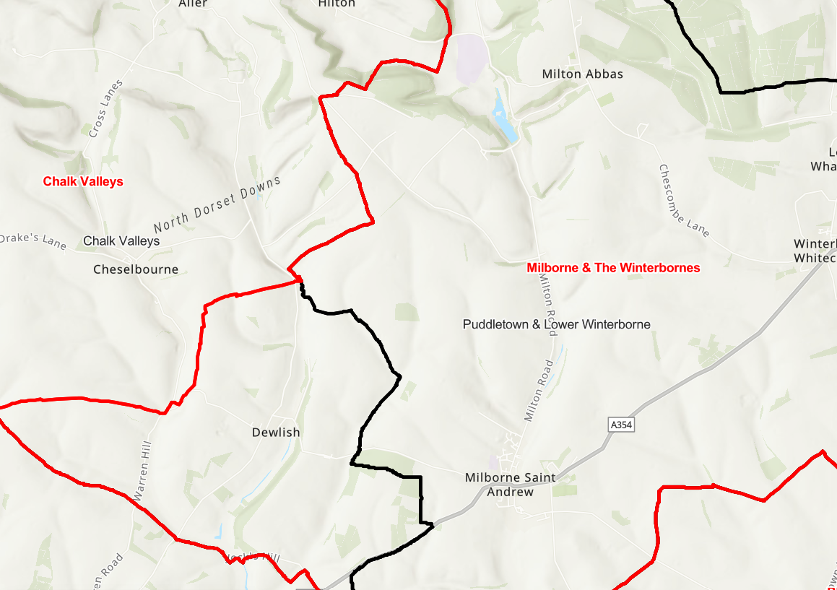

Proposed Ward Boundary alteration

Black line marks existing boundary, the red shows the amended boundary

